Project Documentation: CRM- Vtiger
📋 Project Overview
This project automates contact creation on a web application using Selenium WebDriver. The automation script logs into the application, navigates to the contacts section, creates a new contact with data from external files, and verifies the successful creation.
🏗️ Architecture
Test Script (createcontacttest.java)
↓
Utilities (FileUtility, WebDriverUtility)
↓
External Data (Properties + Excel Files)
↓
WebDriver (Firefox)
↓
Web Application
Architectural View:
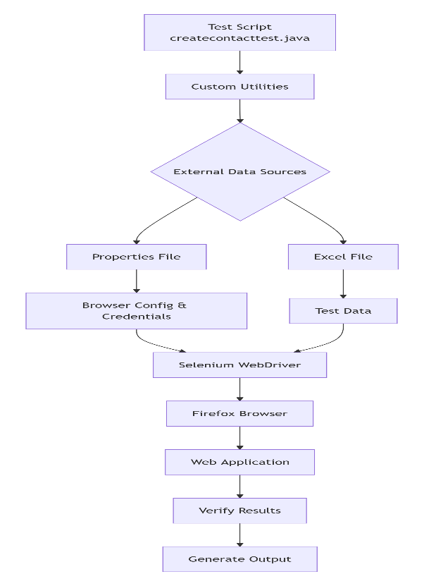
🛠️ Technologies Used
Core Technologies
- Java - Primary programming language
- Selenium WebDriver - Browser automation framework
- Apache POI - For reading Excel files (.xlsx format)
- Java Properties - For reading configuration files
Browser Drivers
- GeckoDriver - For Firefox browser automation
- Firefox Browser - Target browser for execution
Development Tools
- Eclipse/IntelliJ IDEA (IDE for Java development)
- Maven/Gradle (Dependency management - inferred)
Custom Utilities
- FileUtility - Custom class for file operations
- WebDriverUtility - Custom class for WebDriver actions
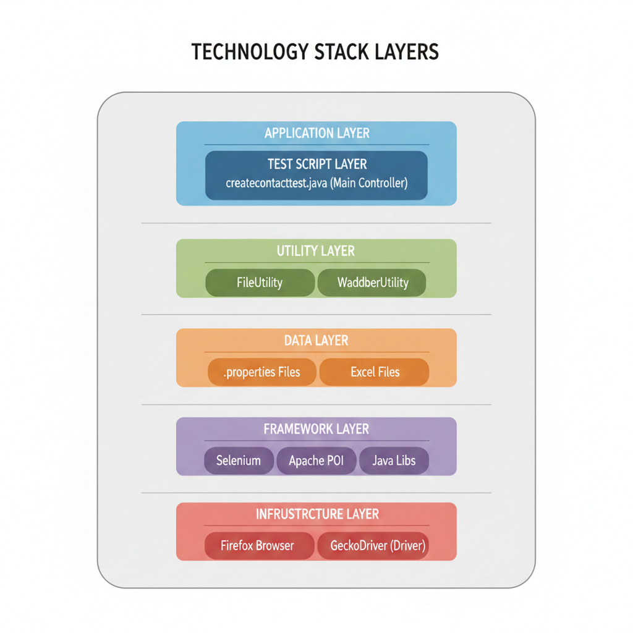

🔧 How the Code Works
1. Setup Phase
- Browser Initialization: Opens Firefox browser in maximized mode
- Wait Configuration: Sets implicit wait for 15 seconds
- Navigation: Loads the application URL
2. Data Loading
- The script reads data from two sources:
  - Properties File (commondata.properties):
- properties
- browser = firefox
- url = http://application-url.com
- un = username
- pwd = password
B. Excel File (Test Script Data.xlsx):
- Reads contact details from "details" sheet
- Fetches specific cells from row 4 for contact information
3. Login Process
- Locates username and password fields
- Enters credentials from properties file
- Clicks the login button
4. Contact Creation
- Navigates to Contacts section
- Clicks "Create Contact" button
- Fills contact form with data from Excel:
  - First Name, Last Name, Title
  - Phone, Email, Dates
  - City, State information
- Clicks Save button
5. Verification
- Verifies if contact was created successfully
- Compares entered last name with displayed last name
6. Cleanup
- Performs logout
- Closes the browser
🚀 Execution Flow
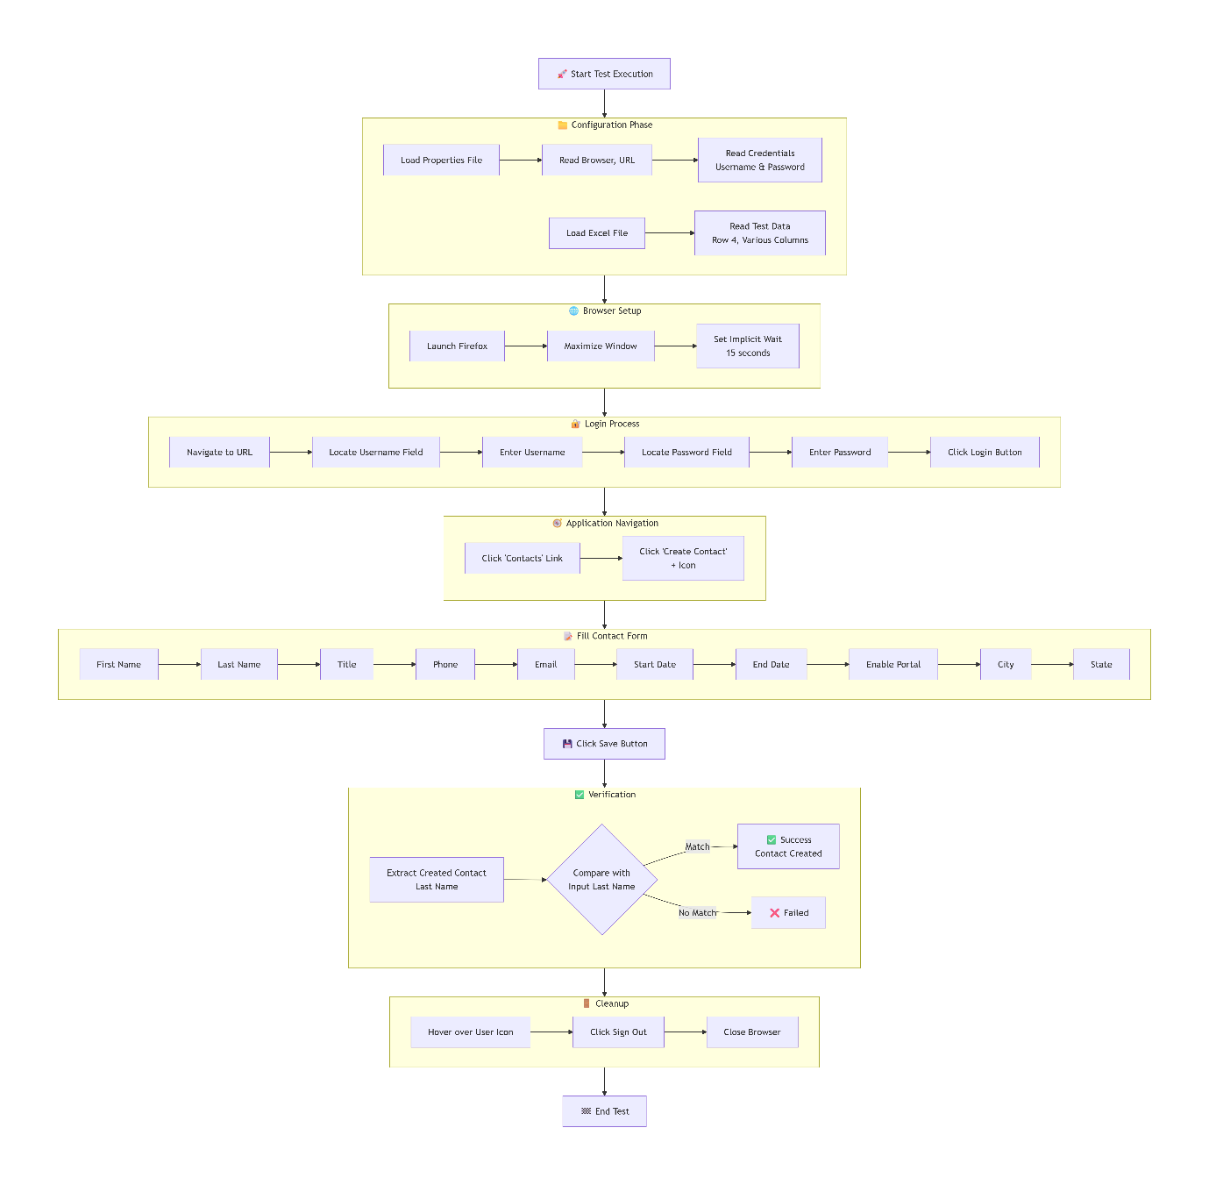
📊 Test Data Flow
text
Excel File → FileUtility → Test Variables → Web Form Fields
↓
Properties File → Login Credentials → Application
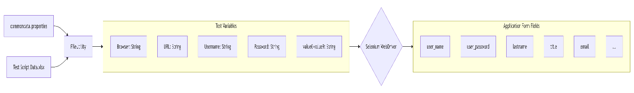
🔄 Key Operations
File Operations
- Properties File: Stores environment variables and credentials
- Excel File: Stores test data (contact information)
- Utility Classes: Abstract file reading complexities
Web Operations
- Element Location: Using CSS selectors, XPath, IDs, and names
- Form Interaction: Text entry, button clicks, dropdown selection
- Navigation: Page transitions and menu interactions
- Verification: Element text comparison for validation
⚙️ Custom Utilities Explained
FileUtility Class
- getdatafrompropertyfile(): Reads key-value pairs from .properties files
- getdatafromexcelfile(): Reads specific cells from Excel sheets
WebDriverUtility Class
- hover(): Handles mouse hover actions (used for logout)

📝 Best Practices Implemented
- Data Separation: Test data stored separately from code
- Reusable Utilities: Common operations in utility classes
- Explicit Waits: Proper element wait strategies
- Resource Management: Properly closes files and browser
- Verification Points: Validates critical operations

